***Report 4379 Feral Pig Processor JRA 2/4/2023***

**Introduction:**

This is an introduction to a system potential able to dehydrate, gelatinize, blend, de-ash and de-hair, animal feed, poultry feeds and aquaculture rations, sourced from (300 mm sized) feral pig parts and offal. This for the processing of either the entire raw carcase parts or the same parts as hydrolysates. In the event that the fat content be too high for the preparation of a compound feed, it may be more lucrative to co-blend the feral pig parts with grains such as sorghum, corn, wheat or sunflower in order to deliver a screened, highly digestible compound feed ration, together with a supplementary fertilizer stream..

**Constituent parts:**

Its constituent parts would consist of

1. A pre breaker, to reduce 300 mm parts to 40 mm dices.
2. This would be mounted on top of a 1 cubic meter holding bin with ribbon auger.
3. A Kx1 dehydrator to evaporate 200 litres of water per hour.
4. A combination cooler/screen facility in order to not only cool the meal but also to remove hair , bone and fibre by the use of gravity separation.

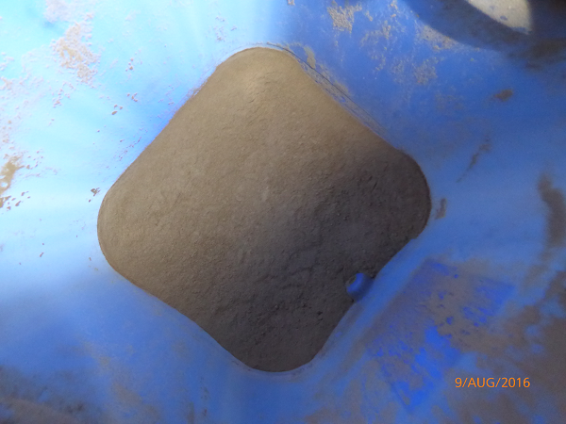

**Final collector**

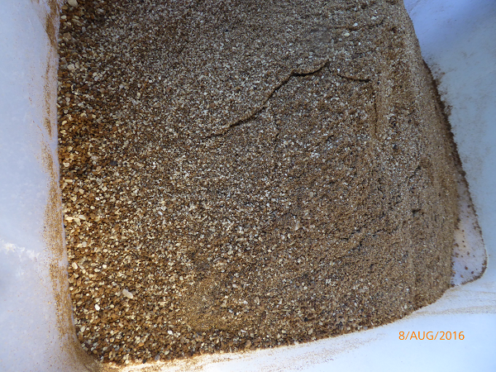

**First collector**

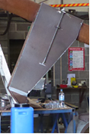

**The adjustable collector**

1. All able to be mounted on a large trailer with a hydraulic tilting ram or mounted in situ at ground level.

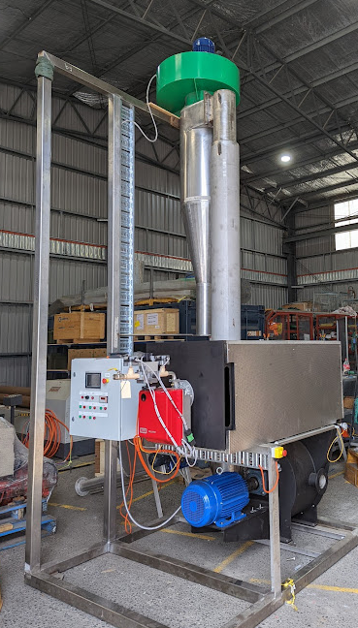

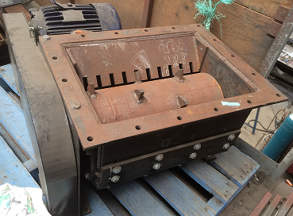

The 10 kW sizer to reduce parts from 300 mm to 40 mm

This unit to be mounted over the top of infeed bin.

**Operation:**

In the attached mass balance, we present the option the option where we process a co blend with roller-cracked sorghum to produce a compound feed that could be suitable for barramundi feeds/poultry/crocodile and pet food markets at a value in excess of $1000 per tonne.



**Processing costs**



Should the compound feed option be needed then the weight of grain needed for the co blending should be between 20 to 30% of the weight of the feral pigs.

It is suggested that having the roller grain crushed before delivery could be beneficial in terms of increased product density and therefore transport and storage cost. Nevertheless roller crushers are fairly cheap and this device is critical in terms of getting the moisture into the endosperm for effective gelatinization.

Approximate cost for the 3 capital items

1. The Aroma NZ Kz1 dehydrator **AUD $113,000**
2. The Combo using extra air from upgraded fan and two product streams **AUD $22,000**
3. 10 kWhr sizer **AUD $21,000**

* GST needs to be added
* Ex factory